**Merchant Settlement: must be done before 10:00PM.**

**1st one kicks out at 8:00pm and the 2nd one kicks out at 9:00pm. If you see error(s) on the 1st run, then fix it so it gets settled when the 2nd run. The 1st one doesn’t generate the report below but will throw error if there’s one.**

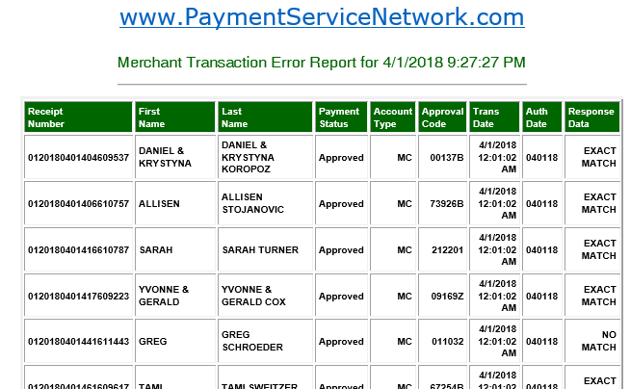

==============================================================================

When you receive "*** PSN Batch File Settlement ERROR" email, then check the "Merchant Transaction Error Report" and see what's on the report. DO NOT run any script until you see the "**Merchant Transaction Error Report**" (above) which gets generated after 9:00 PM.

**\*If you DO NOT see the above report by 9:40pm, text Norman and find out if settlement is still running. Usually, it doesn’t run that long.**

**If the report is clean, there’s nothing on it, then you’re very much done with settlement.**

**Before running the Run_Merchant_Settlement script, call tsys to see if they have received the transactions on the Merchant Transaction Error Report. If they did then do not run the script. Notify Norman of the issue. The issue here is that tsys already received these transactions but they still on the report. Rerunning the Run_merchant_settlement script again will resend the transactions and create duplicate.**

If the Merchant Transaction Error Report (above) is clean but there are merchants on the Batch Settlement Error Report as shown below, then call tsys to verify whether the batch, in this case batch #200, has been successfully settled. Following the procedures for calling tsys below.

Once confirmed that batch has been successfully settled then run the **run_merchant_settlement_for_QD_merchant.vbs** to prevent QD in the subsequent run. The script will ask for the merchant number which can be found in the report below.

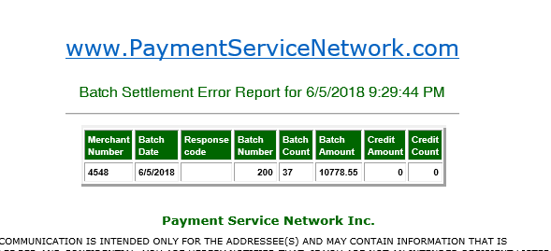

**Follow the instructions below if there are ERRORS on the report:**

1. **Common Errors include:**
2. **QD – Means there’s duplicate in the batch**.

To fix it, run the run_merchant_settlement_for_QD_merchant.vbs script. If issue is not fixed, then call tsys to see what the error is and then report it to Norman.

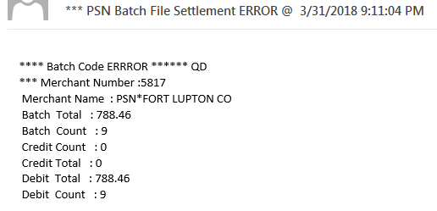

1. **RB – Either the Auth Date or Response Code is invalid –** If the Auth Date is invalid or the Response Data is blank for a transaction, you can run the Manual_ReRun_CC_Auth.vbs for that transaction with the Receipt # before running the Run_Merchant_Settlement.vbs. An example of an invalid Auth Date is 0412QD.

*If the transaction is approved, Auth Date and Response Code are looking good, then call tsys to see if they see any issue with that merchant/transaction. If they do, then rerun the Manual_Rerun_CC_Auth.vbs.



1. **Initiated Payment**.

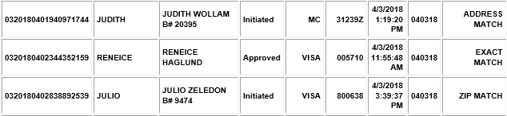

1. Search for the initiated payment using the receipt number on the report. This can be done using the Payment Tracker page.
2. Go into the profile’s payment history, look for an approved payment of the same amount and date – date might be 1 or 2 days off but that’s okay.
3. If one is found, then cancel the initiated payment using the “cancel_initiated_transaction_settleError.vbs”.
4. If not, then go ahead and approve the initiated payment by running “approve_initiated_transaction_settleError.vbs” script. Once approved it should settle after you rerun the run_merchant_settlement.vbs. **For whatever reason, it’s still not settle then try option 1 below.**
5. Use the receipt number to look it up on Transaction Tracker, check the box under Row column and click Process Transaction. Again, check the box under Row column and select Apply Approval Code to Transaction in the dropdown menu under Suggested Actions and click the Process button.

**\*If the transaction is initiated but have no Auth/Approval Code then cancel it through Transaction Tracker.**

1. **Approved FDATA** –When you see these approved FDATA transactions on the report, then run **Run_Fdata_Merchant_Settlement.vbs**. If **run_fdata_merchant_settlment.vbs** doesn’t fix the issue, then run the **Manual_ReRun_CC_Auth.vbs.** Then run **run_merchant_settlement.vbs**.

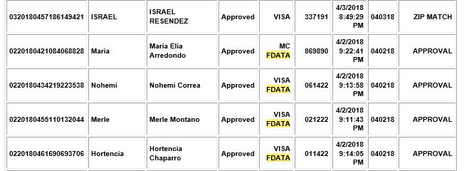

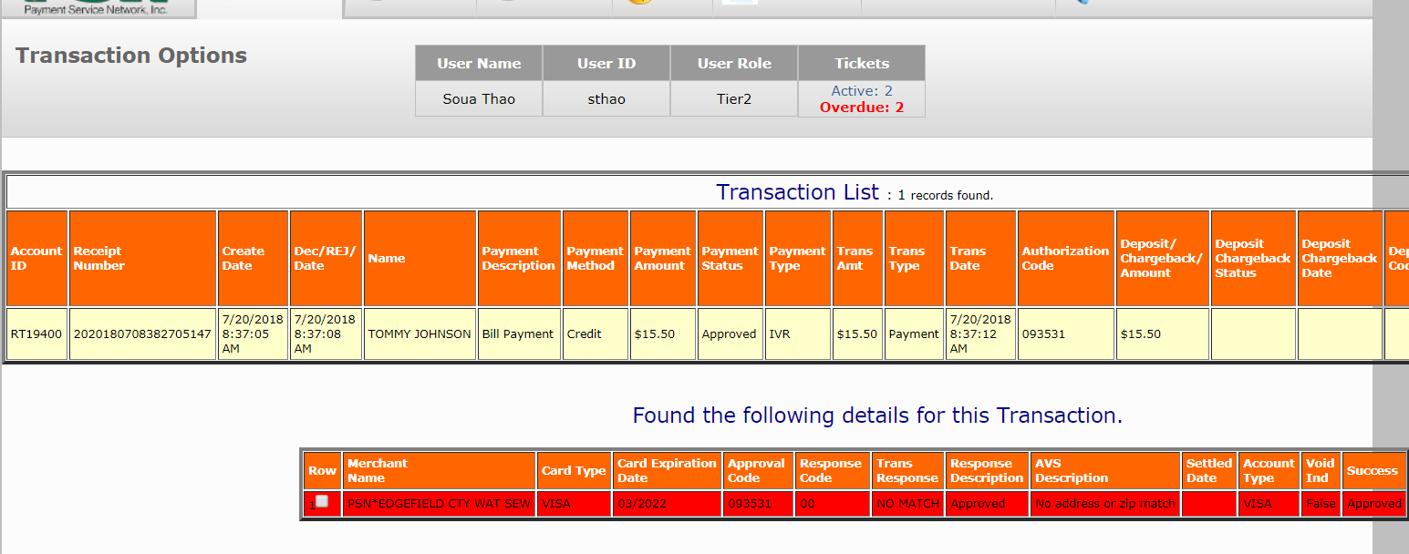

**Once everything is fixed, then rerun the run_merchant_settlement.vbs.**

**If the report is clean then you’re done, else start from #1 again.**

**Procedure for calling Tsys (800-552-8227):**

**Open the two pages in Figure 1 and Figure 2 before calling Tsys.**

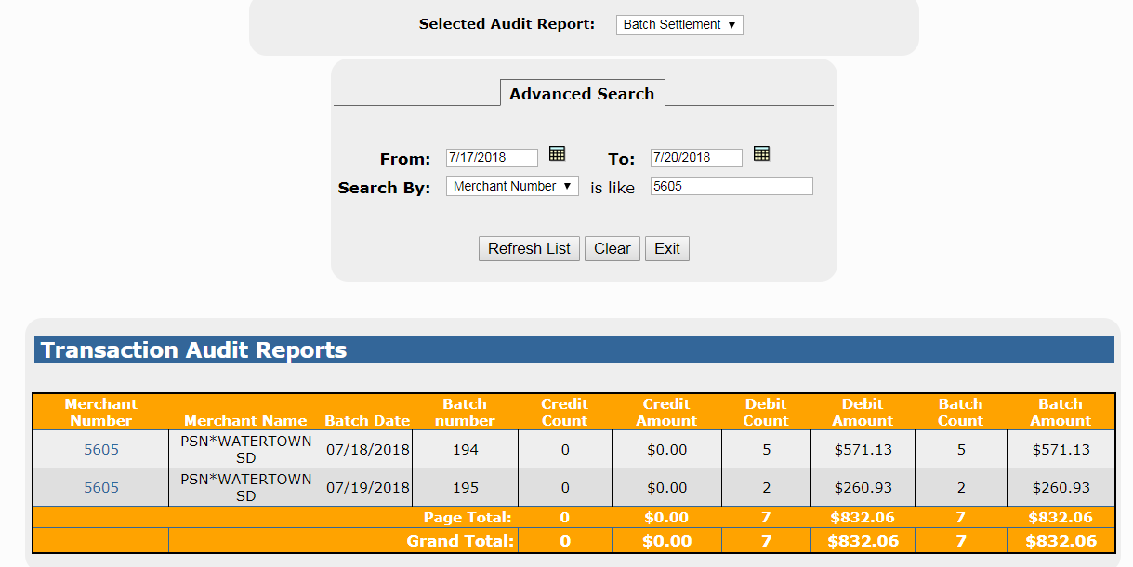

Figure 1

**To get to page in Figure 1, in the manager section, hover over the Payment Tracker and select View Transaction Audits.**

**To get to page two in Figure 2 below, in the manager section, hover over the Account Management and select View Merchant Information, click Options (far right), View/Edit Merchant Info in the popup as seen below.**

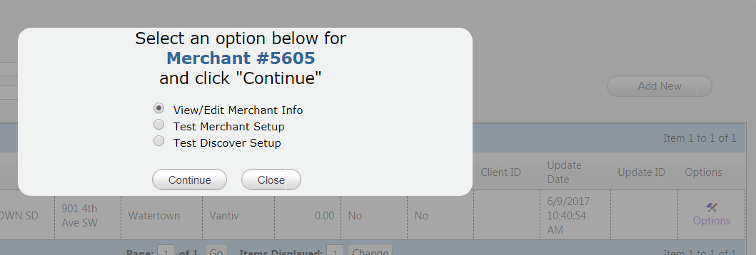

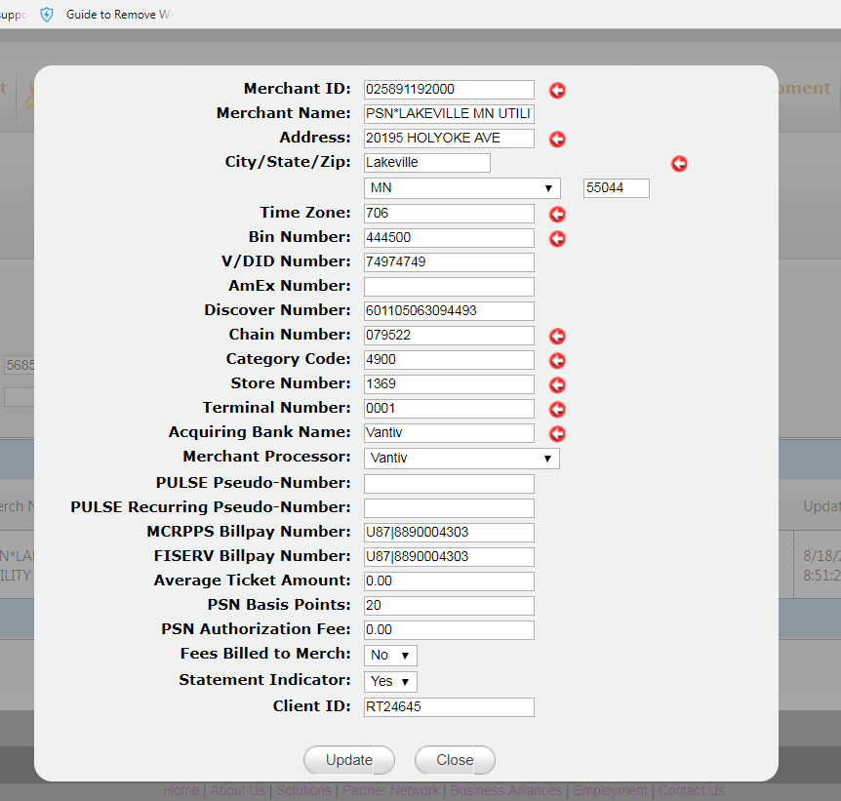

V # and business address can be found here.

Figure 2

**Whoever answer the phone will ask you to verify the V # and business address.**

Figure 2 above provide you with **V # and business address.**

Figure 1 above provides you the batch # in question for that merchant. Ask them if the batch is successfully settled. Also, verify the transaction count and amount with tsys to see if they match what’s on this page and report to Norman if they’re not.

**Summary of scripts for the merchant settlement:**

=> **Run_Merchant_Settlement.vbs** – Run this when there's no other error from the initial run or on the report.

=> **Run_FDATA_Merchant_Settlement.vbs** - Run if, Account Type is FDATA and Trans Time is before 9:00 PM. After running the **Run_FDATA_Merchant_Settlement.vbs** and still doesn't remove the items from the report then run the **Manual_ReRun_CC_Auth.vbs** for FDATA error with the receipt number associated with it and then rerun the Run_FDATA_Merchant_Settlement.vbs script.

=> **Manual_ReRun_CC_Auth.vbs** - Run this script, if AUTH DATE/Response Code is invalid.

=> **Run_Merchant_Settlement_FOR_QD_MERCHANT.vbs** - Run this script if the "*** PSN Batch File Settlement ERROR" email displays "**** Batch Code ERRROR ****** QD", then run Run_Merchant_Settlement.vbs. This script will change the Response_CD to “GB” which means it’s been settled and do not resend it.

=> **Merchant_Settlement_rpt.vbs** - Only run this to generate the report.

**\*If settlement is not done before 10:00pm, then email Krystal and Norman using the following format.**

==========================================================================

Krystal,

Settlement finished late for the below merchant.

Merchant Number: 5492  
Merchant Name: PSN*KINGSVILLE TX UTILITY  
Batch Total: 6508.78

==========================================================================

**\*For whatever reason you cannot get the settlement done for the night, then make sure to email Krystal and SAM.**

**\*Chargeback transaction should not be on the report. Email Norman to have them removed.**

**Merchant trouble shooting:**

We will need to modify this page.  Quick fix - I think

<https://10.1.103.223/manager/TransactionAudits.aspx>

-Payment Tracker | View Transaction Audits (change name to View CC Batch Settlement)

-Add Response_cd and show

-update date and time so we know when it settles.

Also, a Delete option shows when the Response_cd is not "GB".

What happens when you click delete?  does it delete batch and remove all settled transactions associated with it (move null to settled date and 0 to batch number).

When you click on the merchant number link it pulls the total transaction associated with the batch. Can I get the totals on here?  Change Process link on this page to View details)

Add a second option to approved batch when the response is not "GB" Change Response_cd to "GB" (only if number of items associated with the batch matches the batch settlement total)